EDGE INTELLIGENCE
ASSIGNMENT NO: 1

DONE BY
DHAYANIDHI R S
[25MML0025]
STEP 1: Importing Libraries and Loading the Dataset
Explanation:
In this step, we set the dataset base path and verify that all the required components exist:
- train/ folder
- test/ folder
- labels.csv
- sample_submission.csv
We also attempt to load labels.csv to ensure it is readable.
This step confirms that data is available before performing any preprocessing.
Problem Faced?
✔ No issues here
✔ Dataset is found successfully
✔ CSV loads correctly

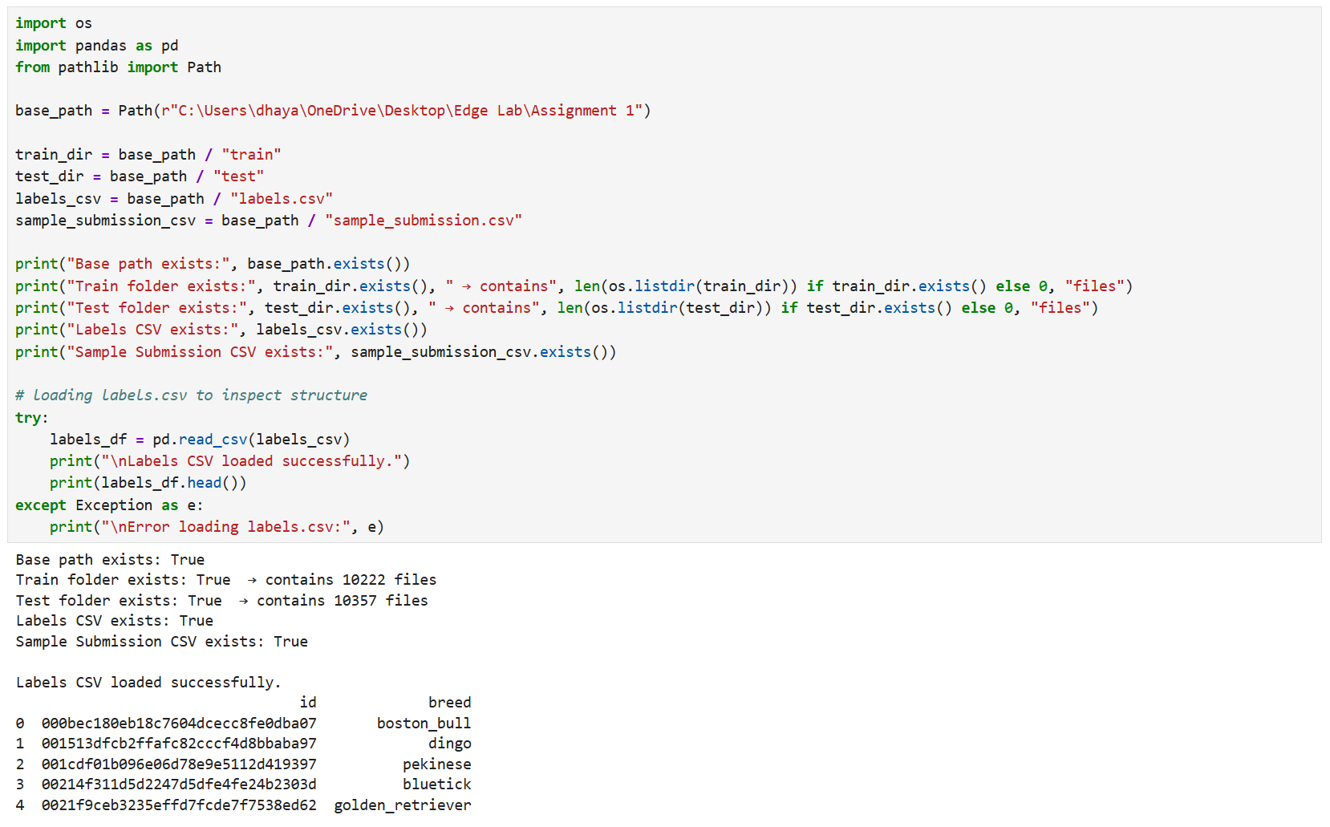
STEP 2: Detecting Corrupted or Unreadable Images
Explanation:
Before performing any preprocessing, it is important to check whether any images in the dataset are corrupted or unreadable.
Corrupted images can cause errors later while:
- Inspecting shapes
- Resizing
- Normalizing
- Feeding into a model
PIL.Image.verify() helps detect such files. If an image fails verification, it is added to the corrupted_images list for removal or skipping.
Problem Faced?
✔ No corrupted images were found.
✔ This means all files are safe to proceed for further preprocessing.

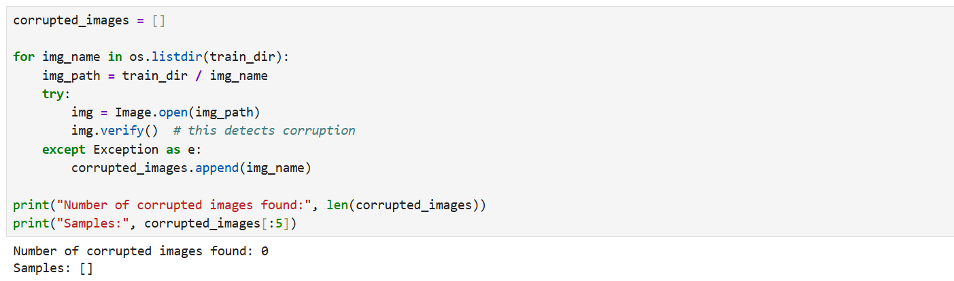

STEP 3: Inspecting Image Shapes (Wrong Approach)
Explanation:
A common beginner mistake is to assume that all images in a dataset have the same dimensions.
In reality, most raw datasets contain images of varying:
- widths
- heights
- number of channels
In this step, we attempt to load the first 50 images and inspect their shapes.
This shows that the dataset is not uniform, which is a problem for ML/DL models.
Problem Faced?
❌ Attempting to stack images into a single NumPy array failed.

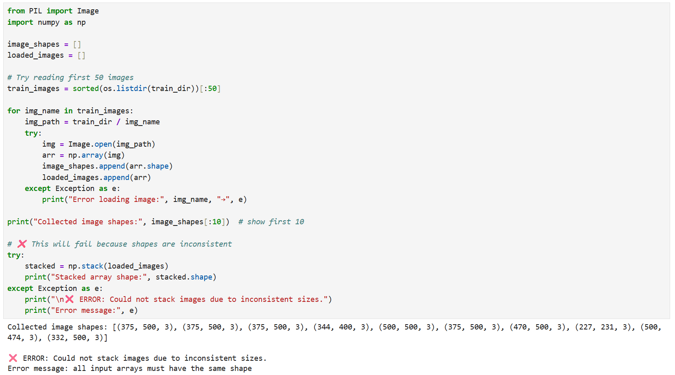

STEP 3.1: Checking Unique Image Shapes (Correct Approach)
Explanation:
Before resizing or preprocessing the images, it is important to understand how much variation exists in the original dataset.
In this step:
- We load the first 200 images
- Convert each to a NumPy array
- Extract its shape
- Store unique shapes in a set
This helps confirm the dataset contains images with many different sizes, supporting the need for consistent preprocessing
Observation:
✔ A large number of unique shapes were found (many different width × height combinations).
✔ Confirms that the dataset is inconsistent and cannot be used directly for ML/DL.
✔ Preprocessing is required to standardize input dimensions.

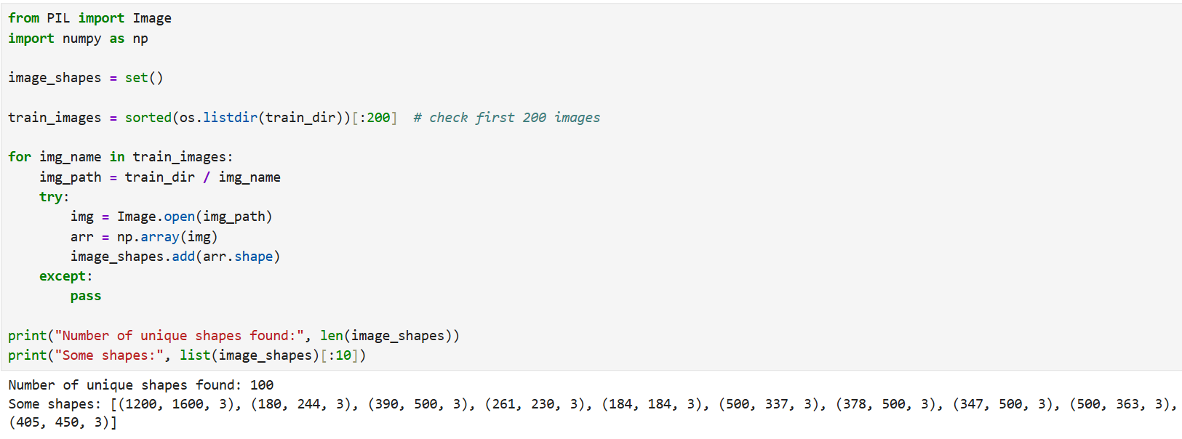

STEP 4: Wrong Approach to Resizing Images
Explanation:
A common mistake is to resize images directly to a fixed size (e.g., 224×224) without handling other important issues. Typical omissions include:
- Not converting grayscale images to RGB, which can leave some images with shape (H, W) instead of (H, W, 3).
- Not ensuring consistent resizing across all images (some might be resized earlier or differently).
- Not checking for read/load errors (some images may fail to open or be corrupted).
- Ignoring images with an alpha channel (RGBA) which produce (H, W, 4) shapes.
Because of these, blindly resizing every file to (224, 224) can:
- produce stretched/squashed images (distortion),
- create inconsistent channel dimensions (grayscale/RGBA issues),
- fail silently if an unreadable image is encountered,
- and ultimately hurt model performance.
Problem Faced?
✔ Images become (224, 224, 3) (or sometimes (224,224) or (224,224,4) if channels differ).
❌ Images are stretched vertically or horizontally when the original aspect ratio is not square.
❌ Grayscale or RGBA files can lead to inconsistent array shapes (missing or extra channels).
❌ If an image fails to open, the error may interrupt batch processing unless handled.
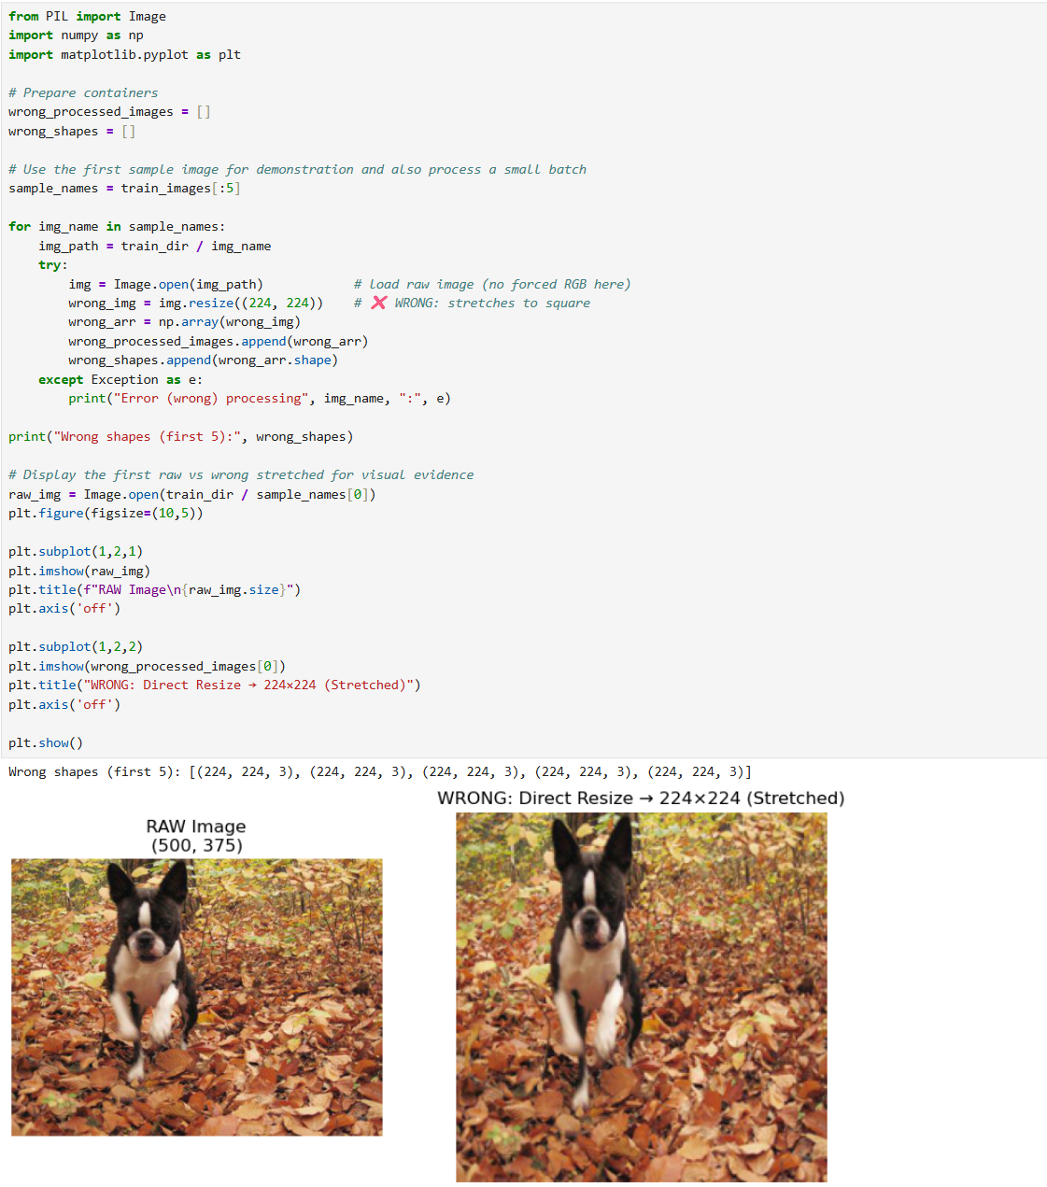

STEP 4.1: Correct Approach using Aspect-Ratio Preserving Resize + Centre Crop
Explanation:
To avoid stretched or distorted images, the correct preprocessing method must preserve the original aspect ratio.
The widely used approach in Deep Learning architectures (such as ResNet, VGG, MobileNet, EfficientNet) follows two steps:
  - Resize the image while maintaining aspect ratio
- The shortest side is scaled to the target size (224 px).
- No distortion is introduced.
  - Apply a centered crop to obtain the final 224×224 image
- This removes excess borders equally from all sides.
- The output is clean, square, and distortion-free.
This method ensures:
- No stretching or squashing
- No black padding bars
- Consistent shapes for ML/DL models
- Maximum preservation of visual information

Observations:
✔ Aspect ratio preserved
✔ Cropped to a perfect 224×224 size
✔ No stretching in height or width
✔ No missing or extra channels
✔ Ready for CNN input

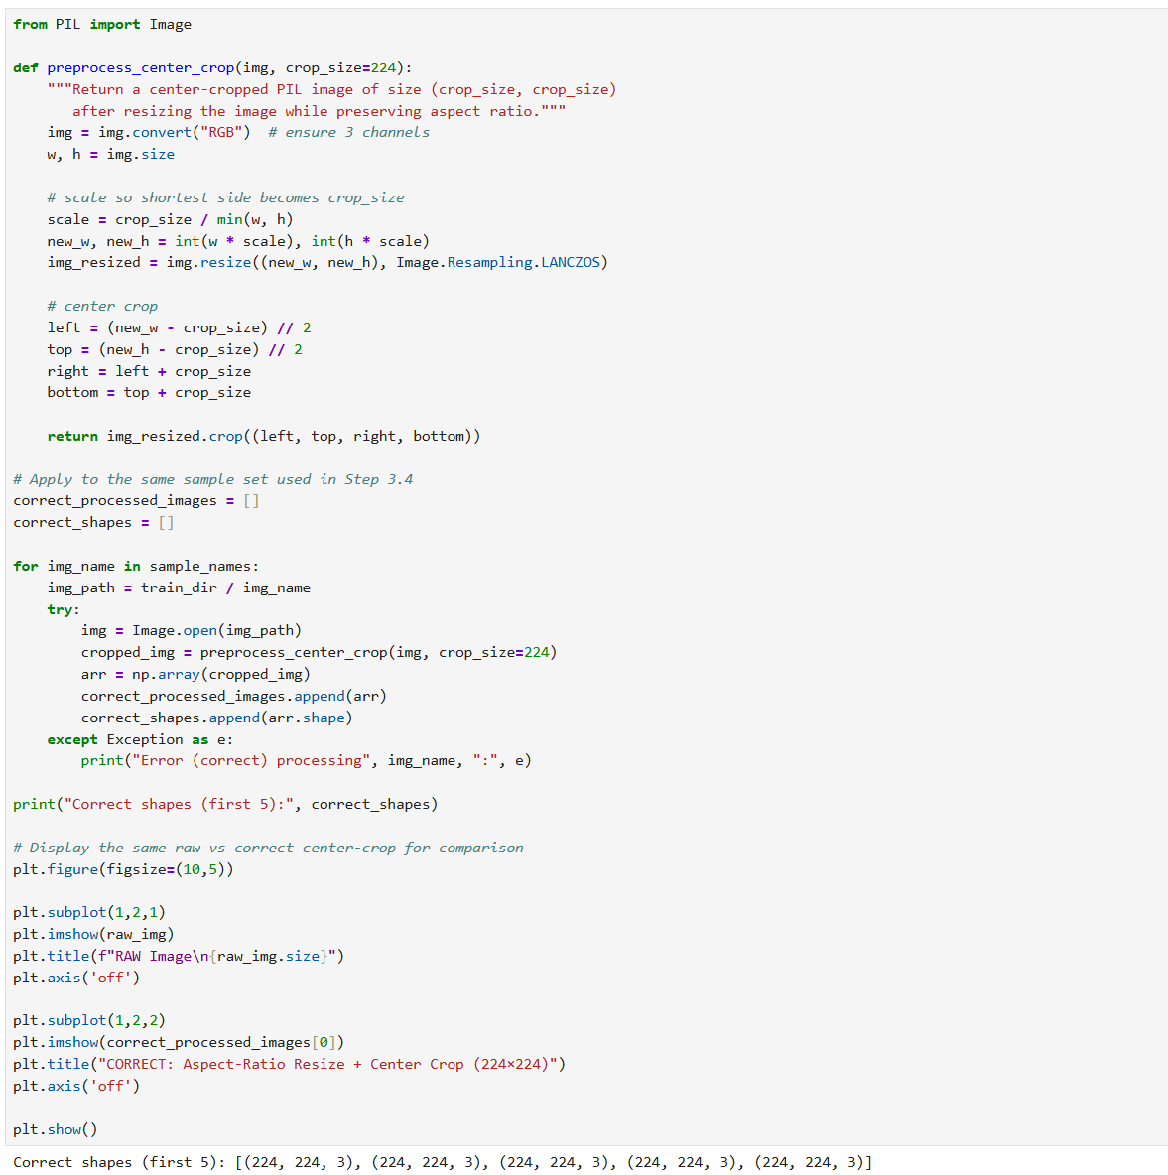
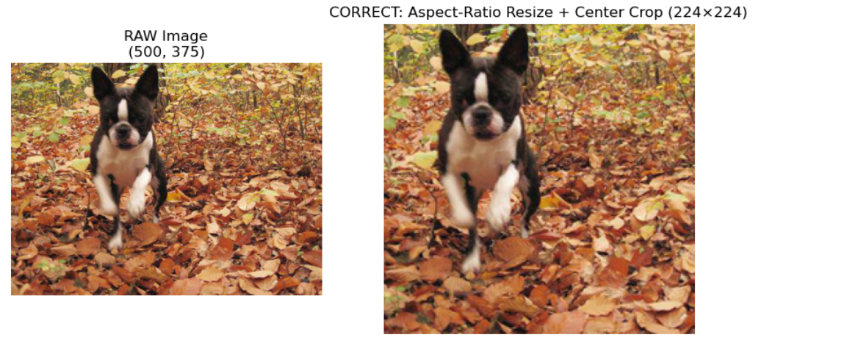

Step 5: Side by side Comparison of the resized images
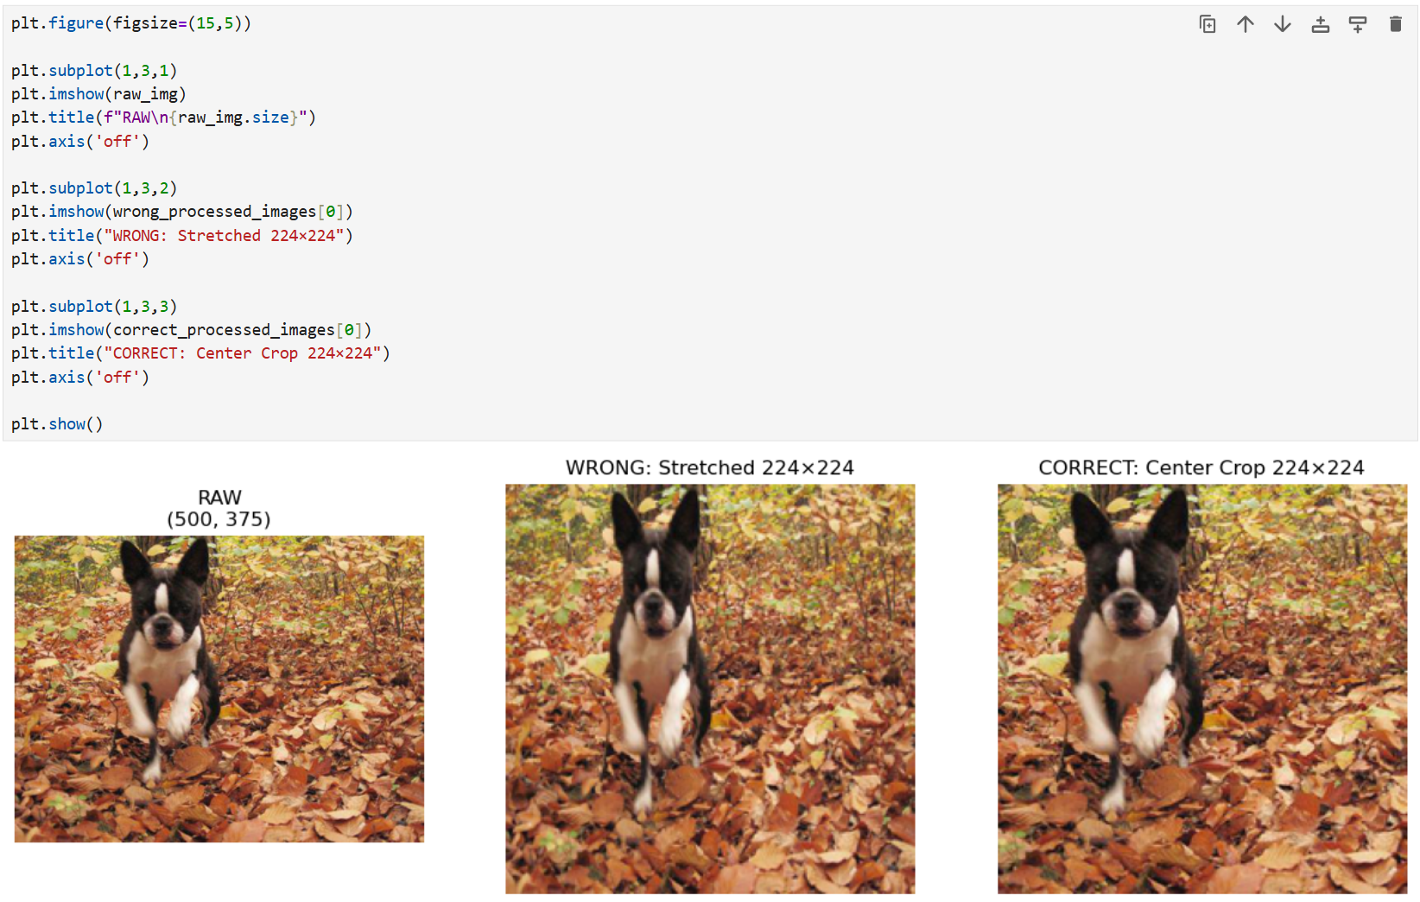

STEP 6: Wrong Normalization
Explanation:
A common beginner mistake is to divide image pixel values by 255 without converting the array to a floating-point type first. If the image array is still uint8, integer division (or operations that preserve integer dtype) may lead to incorrect scaling or silent truncation, producing values that are essentially 0 or 1. This yields poor input for neural networks.
Problem Faced?
❌ dtype remains uint8 (or shows an unexpected type)
❌ Pixel values become effectively 0 or 1 (loss of granularity)
❌ This produces poor-quality input for ML/DL models

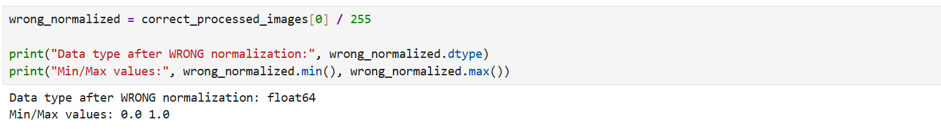

STEP 6.1: Correct Normalization
Explanation:
Correct normalization requires converting image pixel values to a floating-point format before dividing by 255.
This ensures:
- Proper scaling of pixel values between 0.0 and 1.0
- Smooth gradients for neural network training
- No clipping or integer rounding
- Consistent input across the entire dataset
Observation:
✔ dtype becomes float32
✔ Pixel values range between 0.0 and 1.0
✔ No loss of detail
✔ This is now ML/DL-ready input

